ACCOMPLISHMENT REPORT
IT 205 & 205L – Object-Oriented Programming
Month: November – Year: 2025
School Year: 2025 – 2026 1st Semester

DATE | ACCOMPLISHMENT | REMARKS  (Progress and deviations from the plan) *
November 11 – 14, 2025 | Lecture Accomplishments:  - Reviewed key ideas from Module 3 such as constructor functions, object initialization, and the link between constructors and prototypes.  - Gave more simple examples of custom constructors for everyday objects (Student, Course, Product) to strengthen understanding.  - Explained again how to use default values and parameters in constructors to avoid repeated code.  - Discussed common mistakes in using this and new in constructors and how to fix them.  Laboratory Accomplishments:  - Asked students to revise their previous constructor codes based on the lecture review and comments from October.  - Gave a short coding exercise where students created at least two constructors with different properties and methods.  - Let students test instances in the console or browser and check if values and methods work as expected.  - Conducted a short practical quiz on writing simple constructors and using new and this correctly. | Accomplished  (Module 3 was reinforced through review and simple constructor activities; this prepared students for more advanced constructor patterns in the next meetings.)
November 17 – 20, 2025 | Lecture Accomplishments: [EXAMINATION WEEK]  - Introduced basic constructor patterns, such as using the prototype to store shared methods and properties.  - Showed how to refactor code from plain object literals to constructor-based structures for better reuse.  Explained simple examples of constructor “overloading” style in JavaScript using optional parameters.  - Connected constructor design to clean code and maintainability, using short and clear examples.  - Gave an overview of how constructors will later support inheritance in Module 4 (to be covered more in December).  Laboratory Accomplishments: [EXAMINATION WEEK]  - Started a small mini-scenario activity (e.g., Enrollment, Simple Store, or Library) where students designed related constructors.  - Guided students to move shared methods to the prototype, then test if all instances can use the same method.  - Let students peer check each other’s code, focusing on naming, comments, and clear structure.  - Collected the first draft of their mini-scenario constructor code as partial output for Module 3 (to be improved in later weeks). | Accomplished  (Students practiced constructor patterns in a small scenario; final polishing and link to inheritance are reserved for December.)
November 25 – 27, 2025 | Lecture Accomplishments:  - Summarized the main ideas of Module 3: constructor functions, prototypes, simple overloading style, and basic patterns.  - Showed how a constructor-based design can later be extended by inheritance in Module 4 (only simple preview, not full coverage).  - Discussed short case examples where constructor-based design helps manage many related objects (users, orders, records).  - Answered student questions about Module 3 topics and clarified areas that were still confusing.  Laboratory Accomplishments:  - Asked students to improve their mini-scenario constructor project (cleaner code, comments, and better property choices).  - Conducted a guided debugging session, where students fixed errors related to wrong this, missing new, or wrong prototype references.  - Required each student or group to submit an updated version of the Module 3 mini-project with short notes on what they changed.  - Informed students that final checking of Module 3 outputs and the full start of Module 4: Inheritance and Polymorphism will be done in December. | Accomplished  (Module 3 learning was consolidated and mini-projects were improved; remaining Module 3 checks and full Module 4 topics are scheduled for December.)
*Provide relevant documentation such as pictures, summary reports, etc.

Prepared by: Approved:

JUNNIE RYH M. SUMACOT SHERWIN G. CADAY, PhD.
Instructor Program Chair

PROOF/EVIDENCE OF REPORTED ACCOMPLISHMENTS
IT 205 & 205L – Object-Oriented Programming
Month: November – Year: 2025
School Year: 2025 – 2026 1st Semester

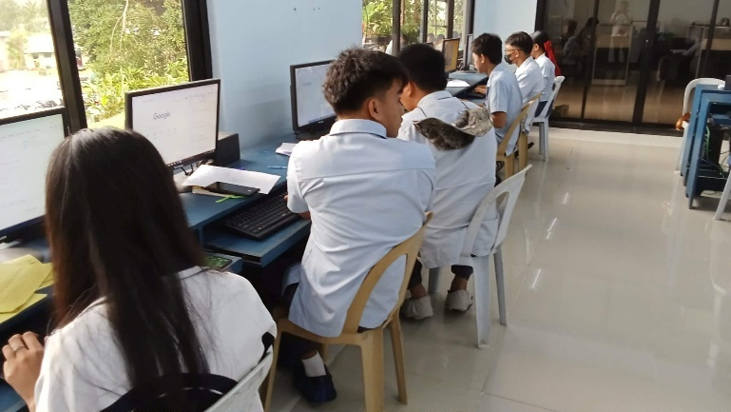


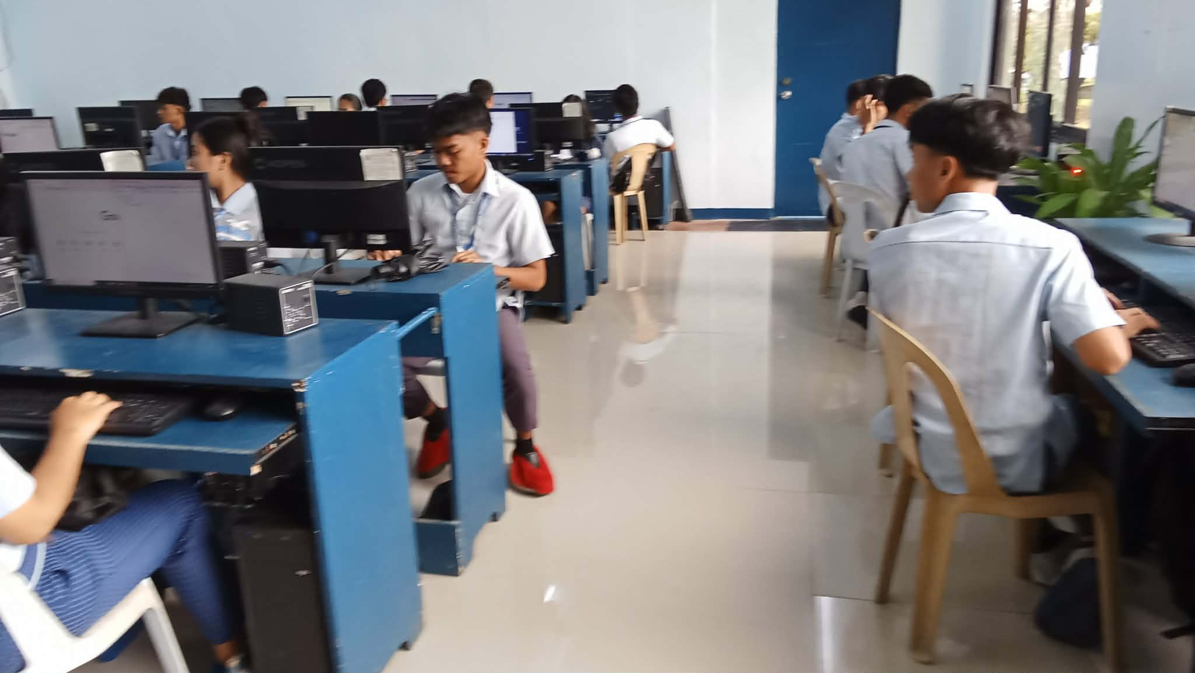


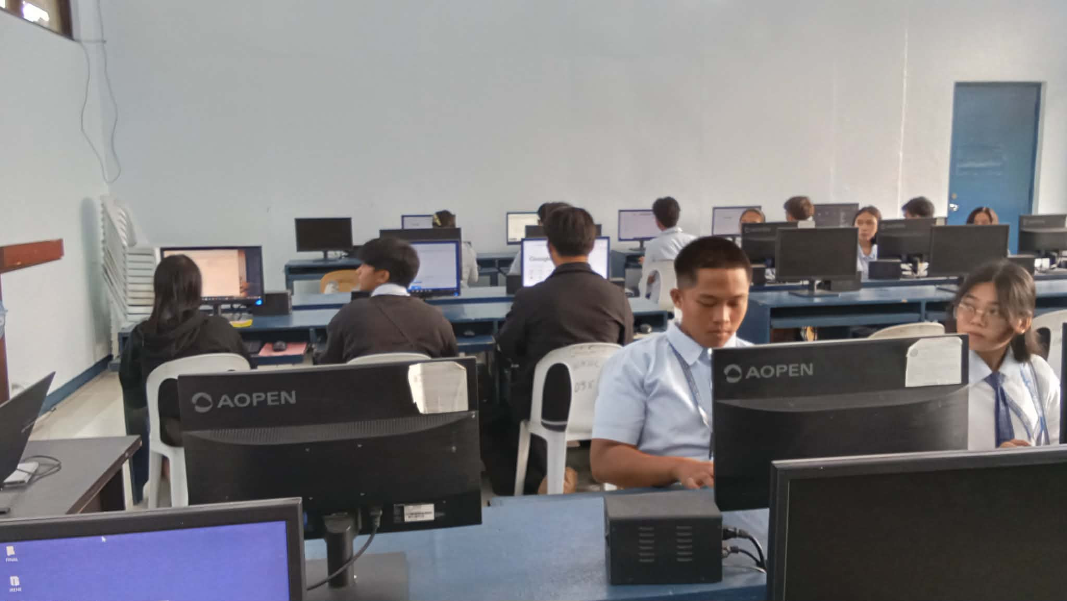

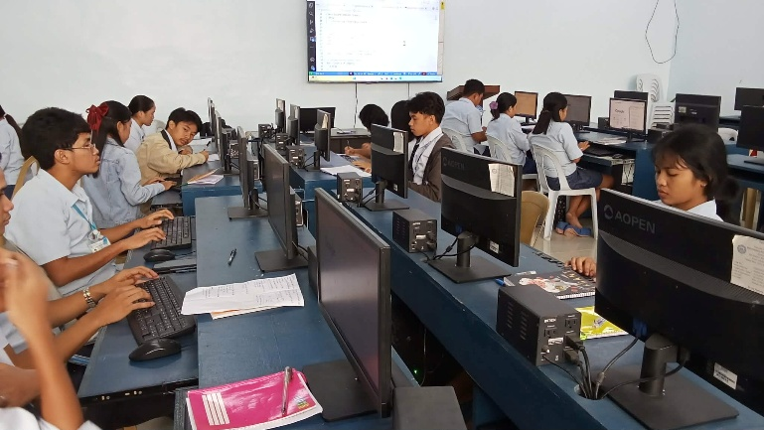


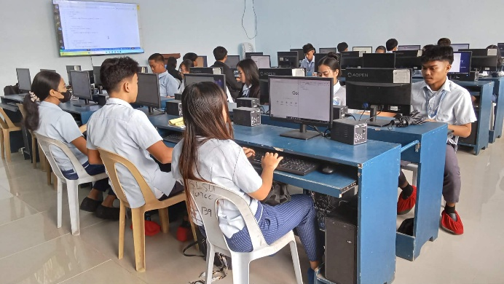
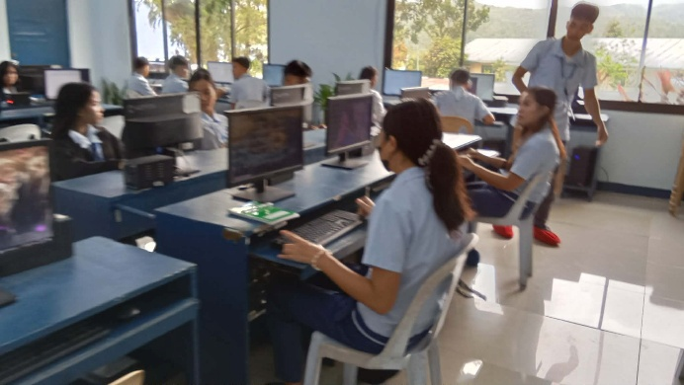

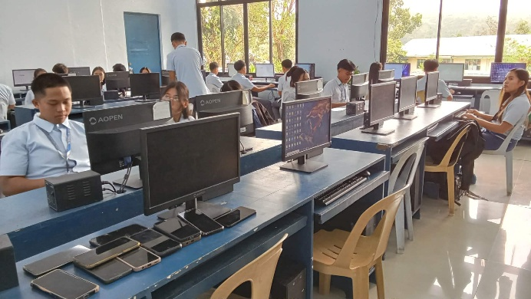
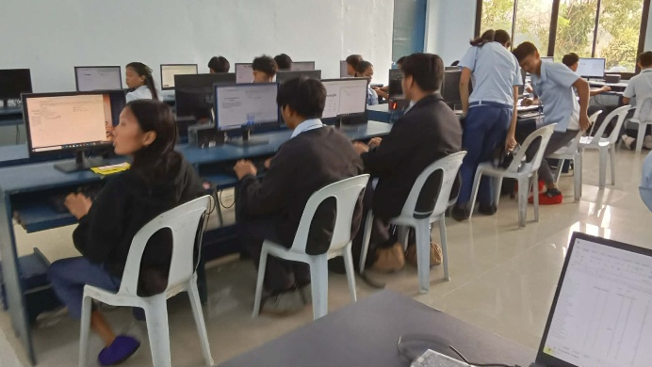

Prepared by: Approved:

JUNNIE RYH M. SUMACOT SHERWIN G. CADAY, PhD.
Instructor Program Chair

